Exercises_1
Dr. Klaib

- Write the Python code to read any number from the user, then print positive if it is positive and print negative otherwise.
- Write the Python code to read any integer number from the user, then print if it is odd or even.
- Write the Python Code to read three numbers from the user, find the largest, then print it.
- Write the Python Code to read a student’s four marks, determine final grade (calculated as the average of four marks), and indicate whether it is passing or failing.
- Write the Python Code to read the lengths of a triangle sides, determine whether it is equilateral, isosceles, multilateral, or not a triangle.
- Write the Python Code to read the values of x and y, then find and print the value of F based on the following equation:
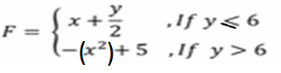

- Write the Python Code to generate randomly two integer numbers [0,100], ask the user to select one of the following operations ( + , - , * , /). Print the result based of his selection.
Example if n1= 100, n2=99, operation=’+’, the result should be 199

