Exercises_1
Dr. Klaib

- Write the C++ code to read any number from the user, then print positive if it is positive and print negative otherwise.
- Write the C++ code to read any integer number from the user, then print if it is odd or even.
- Write the C++ Code to read three numbers from the user, find the largest, then print it.
- Write the C++ Code to read a student’s four marks, determine final grade (calculated as the average of four marks), and indicate whether it is passing or failing.
- Write the C++ Code to read the values of x and y, then find and print the value of F based on the following equation:
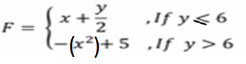

- Write the C++ Code to generate randomly (search on the internet: how to generate random numbers by C++ language) two integer numbers [0,10), ask the user to select one of the following operations (+ , - , * , /). Print the result based of his selection.
Example if n1= 1, n2=8, operation=’+’, the result should be 9

- Write the C++ Code to read the lengths of a triangle sides, determine whether it is equilateral, isosceles, multilateral, or not a triangle.

